

DG TAXUD

ICS2 R1 Operational guidance for postal operators

**ICS2**

Date: 08/04/2021

Doc. Version: 1.20

**Document Control Information**

|  |  |
| --- | --- |
| **Settings** | **Value** |
| **Document Title:** | Operational guidance for postal operators |
| **Project Title:** | ICS2 |
| **Document Author:** | DG TAXUD ICS2 Project team |
| **Project Owner:** | DG TAXUD ICS2 Project team |
| **Doc. Version:** | 1.20 |
| **Sensitivity:** | Public, Basic, High |
| **Date:** | 08/04/2021 |

**Document Approver(s) and Reviewer(s):**

NOTE: All Approvers are required. Records of each approver must be maintained. All Reviewers in the list are considered required unless explicitly listed as Optional.

|  |  |  |  |
| --- | --- | --- | --- |
| **Name** | **Role** | **Action** | **Date** |
| ECCG |  | Approve |  |
| TCG |  | Review |  |

**Document history:**

The Document Author is authorized to make the following types of changes to the document without requiring that the document be re-approved:

* Editorial, formatting, and spelling
* Clarification

To request a change to this document, contact the Document Author or Owner.

Changes to this document are summarized in the following table in reverse chronological order (latest version first).

|  |  |  |  |
| --- | --- | --- | --- |
| **Revision** | **Date** | **Created by** | **Short Description of Changes** |
| 1.20 | 08/04/2021 | DG TAXUD | Document updated after external review and published for acceptance |
| 1.10 | 08/03/2021 | DG TAXUD | Document sent for review to MS and Postal operators |
| 1.00 | 30/06/2020 | DG TAXUD | Initial version |

TABLE OF CONTENTS

1 INTRODUCTION 6

1.1 Purpose 6

1.2 Scope of the document 6

1.3 Target Audience 6

1.4 Structure of this document 6

1.5 Reference and applicable documents 7

1.6 Abbreviations and Acronyms 7

1.7 Definitions 8

1.8 General disclaimer 11

2 Background 12

3 Legal basis 14

3.1 Legal background 14

3.2 Obligation to lodge an ENS 14

3.3 Place to lodge an ENS 14

3.4 Single / multiple filing 14

3.5 Specific waivers from the obligation to lodge an ENS 14

3.5.1 Items of correspondence 15

3.5.2 Items not destined for the EU 15

3.5.3 Goods on all means of transport passing through the territorial waters or the airspace of the customs territory of the EU 15

3.6 Registration of the declarant for ENS lodgement 15

4 Roles and responsibilities 16

4.1 Declarant 16

4.2 Representative 16

4.3 Origin Post 16

4.4 Destination Post 16

4.5 Transit Post 16

4.6 IT service provider 16

4.7 Consignor/sender 16

4.8 Consignee/addressee 17

4.9 Customs Office of first entry/COFE 17

4.10 Customs Office at destination 17

4.11 Carrier 17

5 Postal Business Process Description 18

5.1 UPU EAD Global Postal Model 18

5.2 UPU Communication structures 18

6 ICS2 19

6.1 ICS2 general description 19

6.2 Entry process – Postal business model 19

6.2.1 Steps of lodgement of ENS 20

6.2.2 Risk analysis by customs, including referrals 22

6.2.3 Presentation of goods to customs 23

6.2.4 Control of goods by customs 23

6.2.5 Subsequent customs procedure 24

6.3 Amendments of ENS 24

6.4 Invalidation of ENS 25

7 Postal transit and ICS2 26

7.1 Closed transit 26

7.1.1 Non-EU – EU – EU 26

7.1.2 Non-EU – non-EU – EU 26

7.2 Open transit 26

7.2.1 Non-EU – EU – EU 27

7.2.2 Non-EU – non-EU – EU 27

8 Data requirements 28

8.1 Data requirements – ITMATT 28

8.2 Data requirements − PREDES 29

8.3 Data requirements − Missing data elements 29

9 Annexes 30

9.1 Annex 1 – Mapping data elements ITMATT – ENS 30

9.2 Annex 2 – Mapping data elements PREDES – ENS 33

**TABLE OF TABLES**

Table 1: Reference documents 7

Table 2: Abbreviations and acronyms 8

Table 3: Definitions 10

Table 4: UPU EDI messages in Global Postal Model 18

**TABLE OF FIGURES**

Figure 1: UPU EAD flowchart 18

Figure 2: ICS2 message mapping to UPU EAD global postal model 20

Figure 3: ICS2 R1 - Postal business model -> AC 21

Figure 4: ICS2 R1 - Postal business model -> DNL 21

Figure 6: ICS2 R1 - Postal business model -> referrals 23

Figure 7: Transit scenario 1 26

Figure 8: Transit scenario 2 27

Figure 9: Transit scenario 3 27

Figure 10: Minimum required data for ICS2 Release 1 28

# INTRODUCTION

## Purpose

UPU designated postal operators operating in European Union Member States, have the obligation from 15 March 2021 on, to provide safety and security data in a form of Entry Summary Declaration (ENS) lodged in ICS2 system.

This document provides operational guidance for UPU designated postal operators operating in EU, on entry processes implemented within the ICS2 system.

This guidance also forms an integral part of the overall ICS2 implementation guidance compendium.

## Scope of the document

The scope of the guidance is limited to ICS2 **Release 1 only.** In particular, this guidance covers:

* Explanation of legal basis and requirements for entry process;
* Description of roles and responsibilities of customs and trade stakeholders;
* Explanations of postal flows and business processes;
* Explanations of ICS2 processes;
* Description of postal entry process within ICS2 Release 1;
* Description of presentation process;
* Explanations about invalidation and amendment of ENS filings.

Not in scope of this document:

* Any UPU technical or operational rules and provisions;
* Any IT solutions and/or instructions related to ICS2, coming from other parties than European Commission.

## Target Audience

The intended audience for this document are:

* the representatives of the UPU designated postal operators;
* representatives of the Member States;
* any person involved in the ICS2 project;
* any person lodging an ENS for postal consignments.

## Structure of this document

The present document contains the following chapters:

* **Chapter 1 –** Introduction: describes the scope and the objectives of the document;
* **Chapter 2 –** Background: describes the history of implementation of security and safety measures and systems;
* **Chapter 3 –** Legal basis: describes legal requirements what regards lodgement of ENS filings;
* **Chapter 4 –** Roles and responsibilities: describes actors involved and their roles and responsibilities;
* **Chapter 5 –** Postal Business Process Description: describes postal business processes;
* **Chapter 6 –** ICS2: describes the business processes under ICS2;
* **Chapter 7 –** Postal transit and ICS2: describes document flow in case of postal transit;
* **Chapter 8 –** Data requirements: describes data requirements for postal messages;
* **Chapter 9** – Annexes: describes how to map ITMATT and PREDES with ENS.

## Reference and applicable documents

|  |  |  |  |  |
| --- | --- | --- | --- | --- |
| Ref. | Title | Reference | Version | Date |
| R01 | ICS2 Harmonised Trader Interface Specifications (HTI) |  | 1.15 | 08/01/2020 |
| R02 | ICS2 HTI BPM L4 Process Description |  | 1.12 | 07/12/2018 |
| R03 | ICS2 HTI Information Exchange Specifications |  | 1.15 | 08/01/2020 |
| R04 | REGULATION (EU) No 952/2013 OF THE EUROPEAN PARLIAMENT AND OF THE COUNCIL of 9 October 2013 laying down the Union Customs Code |  |  | 09/10/2013 |
| R05 | COMMISSION DELEGATED REGULATION (EU) 2015/2446 of 28 July 2015 supplementing Regulation (EU) No 952/2013 of the European Parliament and of the Council as regards detailed rules concerning certain provisions of the Union Customs Code |  |  | 28/07/2015 |
| R06 | COMMISSION IMPLEMENTING REGULATION (EU) 2015/2447 of 24 November 2015 laying down detailed rules for implementing certain provisions of Regulation (EU) No 952/2013 of the European Parliament and of the Council laying down the Union Customs Code |  |  | 24/11/2015 |
| R07 | EU guidance on air cargo security referral protocols |  | 1.15 | 24/01/2020 |
| R08 | UPU Postal Transport Guide | UPU |  | October 2018 |
| R09 | UPU standard M41 PREDES v.2 | UPU | M41-7 | 16/02/2016 |
| R10 | UPU standard M33-12 ITMATT | UPU | M33-12 | 17/10/2017 |
| R11 | ICS2 Business continuity plan for Economic operators | ICS2-BCP-EO | v1.00 | 11/02/2021 |

Table 1: Reference documents

## Abbreviations and Acronyms

|  |  |
| --- | --- |
| Abbreviation/Acronym | Definition |
| AC | Assessment Complete |
| ACC3 | Air cargo or mail carrier operating into the EU from a third country airport |
| AEO | Authorised Economic Operator |
| AEOS | Authorised Economic Operator authorised for security and safety |
| CFSS | Common Functional System Specifications |
| CSD | Consignment Security Declaration |
| DNL | Do Not Load |
| DPO D | Designated Postal operator at destination |
| DPO O | Designated Postal operator at origin |
| EAD | Electronic Advanced Data |
| eCSD | Electronic Consignment Security Declaration |
| EDI | Electronic Data Interchange |
| ENS | Entry Summary Declaration |
| EO | Economic operator |
| EORI | Economic Operators Registration and Identification number |
| ETOE | Extra-territorial Office of Exchange |
| EU | European Union |
| FoS | Framework of Standards |
| GHA | Ground handling agent |
| HAWB | House air waybill |
| HRCM | High Risk Cargo and Mail |
| ICAO | International Civil Aviation Organization |
| ICS2 | Import Control System 2 |
| IE | Information exchange |
| ITMATT | ITeM ATTributes message (Name of the UPU messaging standard (M33)) |
| JWGACI | Joint ICAO WCO Working Group on Advance Cargo Information |
| MAWB | Master air waybill |
| MRN | Master Reference Number |
| MS | Member State |
| NES | National Entry System |
| PLACI | Pre-loading advance cargo information |
| PREDES | Pre-advised Despatch (Name of the UPU messaging standard (M41)) |
| RA | Risk analysis |
| RfI | Request for Information |
| RfS | Request for Screening |
| UCC | Union Customs Code [Regulation (EU) No 952/2013 of the European Parliament and of the Council of 9 October 2013 laying down the Union Customs Code] |
| UCC-DA | Commission Delegated Regulation (EU) 2015/2446 of 28 July 2015 supplementing UCC as regards detailed rules concerning certain provisions of the UCC |
| UCC-IA | Commission Implementing Regulation (EU) 2015/2447 of 24 November 2015 laying down detailed rules for implementing certain provisions of the UCC |
| UPU | Universal Postal Union |
| WCO | World Customs Organisation |

Table 2: Abbreviations and acronyms

## Definitions

|  |  |
| --- | --- |
| Term | Definition |
| Air pre-loading risk analysis | Air pre-loading risk analysis is a limited security risk analysis by the customs aimed to identify potential risk of (improvised) explosive device entering into the air cargo supply chain posing threat to the civil aviation (aka ‘bomb-in-a-box’ risk assessment). |
| Pre-arrival risk analysis | Security and safety risk analysis performed prior to the arrival of the goods into the EU. |
| Carrier | Carrier means in the context of entry, the person who brings the goods, or who assumes responsibility for the carriage of the goods, into the customs territory of the Union. |
| Complete ENS | Complete ENS means an ENS containing all required data particulars required by the legislation per specific mode of transport or business model. Complete ENS can be represented either by a full ENS filing or all necessary partial ENS filings that together contain all required data particulars. |
| Customs office of presentation | The customs office locally competent for the approved place of presentation of the goods to customs. |
| Customs office of the destination Post | The customs office where goods are presented to customs for clearance by the postal operator at destination. |
| Entry Summary declaration | Entry Summary Declaration (ENS) means the act whereby a person informs the customs authorities, in the prescribed form and manner and within a specific time limit that goods are to be brought into the customs territory of the Union. |
| ENS filing | ENS filing means either partial or full ENS data set required by the legislation per specific mode of transport or business model. |
| Extra territorial office of exchange | Is an office or facility established for commercial purposes and operated by UPU designated operators or under the responsibility of UPU designated operators on the territory other than their own. |
| House air waybill (HAWB) | A house air waybill (HAWB) is a form of an air waybill that is issued by a freight forwarder, express operator or an agent to its customer. |
| Harmonized System (HS) | Harmonized System of the World Customs Organization for the Classification of Goods. |
| House consignment | In ICS2 this term refers to a created entity based on the information about a consignment from a house level transport contract issued by a freight forwarder, non-vessel operating common carrier or agent to its direct contracting party (customer). |
| House consignment goods item | Goods items (articles in items) which are to be classified under different HS-codes require a separate goods item declaration within the House consignment of an ENS filing. |
| High Risk Cargo and Mail Screening (HRCM screening) | High Risk Cargo and Mail Screening (HRCM screening) is a notification communicated by the customs authority of the RMS to the person filing (and the carrier under certain conditions) that the goods concerned shall need to be screened as a high risk cargo and mail, in accordance with the point 6.7.3 of the Annex to Commission Decision C (2010) 774 of 13 April 2010, before being loaded on board of an aircraft bound to the customs territory of the Union. |
| Items of correspondence | Items of correspondence covers postcards and letter post items, containing only documents and not containing any goods. The explanation of the term “items of correspondence” is defined in UCC (UCC-DA, Article 1 (24, 26)). The UCC definition may deviate from the UPU definition. |
| International Mail Processing Centres | International Mail Processing Centres or facilities for the processing of international mail exchanged either in order to generate or receive mail dispatches or to act as transit centres for international mail exchanged between other UPU designated operators (may be either an office of exchange or a mail unit or both). IMPC is typically both OE and mail unit. |
| ITMATT | ITeM ATTributes message is used to support the electronic communication between postal handling organisations on individual postal items. ITMATT is limited to information for customs and security purposes and corresponds to the content of CN22/CN23 forms. |
| Mail unit | Mail unit creates and receive consignments (term consignment within UPU is linked to transport: all receptacles assigned to a specific transport). |
| Master Air Waybill (MAWB) | Master air waybill (MAWB) is a form of an air waybill that is issued by the carrier to its direct contractual party (customer). |
| Master level ENS filing | This is a partial filing, which contains information derived from a MAWB or MboL, depending on the mode of transport.  Postal dispatch can consist from one or several postal receptacles, which (if possible) shall be forwarded by the same transportation.  The master level transport document is called Delivery Bill and is intended for transport of closed mails by air or by surface. Delivery Bill includes total number and total weigh of all receptacles. Receptacles may be from a single dispatch or many dispatches, originating from same operator-origin or being forwarded as closed transit. |
| Master Reference Number | Master Reference Number means the registration number allocated by the competent customs authority to declarations or notifications. The MRN is assigned for each ENS filing registered by the customs authorities and communicated back to the person filing. |
| Member state | All European Union Member states and other countries and territories applying EU customs legislation. |
| Member State of control | Member State of control has a final decision on whether to actually control the goods or not, taking into account the results of risk analysis and control recommendation of the RMS. |
| Office of Exchange | Key principle of international mail is that designated UPU postal operator establishes ‘offices of exchange’ (OE) from which all outbound mail is dispatched and at which all inbound mail is received. Postal operators can have one or several OEs. OE creates and receives dispatches and PREDES messages. |
| Person filing | Person filing means any person that submits to the customs authority ENS filing in its complete or partial content and other notifications in the prescribed form and manner. This person can be any person that issues bill of lading or air waybill and can be either carrier, NVOCC (i.e. freight forwarder), or any person identified by the legal provisions obliged to submit required particulars of ENS to the customs and can include postal operator, consignee stipulated in the lowest bill of lading. Person filing also includes representative of any of the persons mentioned above that submits the ENS filing in its complete or partial content to the customs authority on behalf of the person that it is representing. |
| PLACI data | Pre-loading advance cargo information (PLACI) comprise consignor name and address, consignee name and address, number of packages, gross weight, goods description and transport reference number (HAWB/MAWB). |
| Postal item | Goods other than items of correspondence contained in a postal parcel or package and conveyed under the responsibility of or by a postal operator in accordance with the provisions of the Universal Postal Union Convention. |
| Postal receptacle | Postal receptacle is a physical device, which can be used to contain or carry mail to assist in its handling or transportation as a unit.  Receptacle ID shall have the information about all house consignments (items with goods) inserted into it, following the principle that every item identifier (ID S10 barcode) is scanned into the receptacle. |
| Presentation | Presentation to customs means notifying customs that goods under customs supervision have arrived and are physically available for a (potential) control at the customs office of presentation. |
| PREDES | PREDES is pre-advice of dispatch information, sent electronically. PREDES is an EDI message, defined in UPU standard M41. |
| Transit (closed transit) | Closed mails, passed to UPU member countries, with their obligation to forward that mails always by the quickest routes and the most secure means, which they use for their own items. |
| Transit (open transit) | Transit through intermediate country of items, whose number or weight does not justify the make-up of closed mails for destination country. |

Table 3: Definitions

## General disclaimer

This guidance document is of an explanatory and illustrative nature. Customs legislation takes precedence over the content of this document and should always be consulted. The authentic texts of the EU legal acts are those published in the Official Journal of the European Union. There may also be national instructions.

# Background

Safeguarding the global supply chain is critical. Security measures must protect involved stakeholders from risks that could endanger lives, cause losses – in short, security measures shall eliminate all lethal threats.

After the Yemen air cargo security incident in 2010, the aviation ACC3 regime was put in place. The ACC3 (Air cargo or mail carrier operating into the EU from a third country airport) regime, established by Commission Implementing Regulation (EU) No 2015/1998 and Decision C(2015) 8005, stipulates that cargo and mail entering the EU on an aircraft must be controlled according to EU air cargo screening obligations unless it comes from an airport located in a country exempted from these rules.

EU Customs Security Legislation was implemented in 2011, giving the customs authorities of the EU Member States a legal responsibility to ensure that a risk analysis is carried out and finalized primarily for security and safety purposes.

Operationally, customs authorities today use a system of advance cargo declaration (Import Control System – ICS) that is linked to their national risk systems. They must make a decision in terms of necessary measures to be taken to mitigate any identified risk.

The next generation EU security legislation is built upon the experiences and findings obtained from many international pilots and projects on the security and safety issues.

Internationally, the PLACI principles: pre-loading advanced air-cargo information (PLACI data set) submission and three referral types for air-cargo are in place. These principles were taken on board of the WCO SAFE Framework of Standards in 2015.

EU Customs pre-arrival security and safety programme is supported by the Import Control System 2 (ICS2). Implementation of this system represents core EU customs instrument for managing entry security and safety border controls.

ICS2 system will become operational in three releases. This approach enables economic operators to begin declaring safety and security ENS data to ICS2 based on phased requirements and type of services they provide:

* ICS2 Release 1, start date is 15 March 2021

Designated postal operators, established in EU, shall provide the minimum set of advanced data in the format of the electronic ENS to the ICS2, for all goods in consignments finally destined to the EU that they bring into the EU customs territory. This includes items, sent under UPU rules from ETOEs and items, sent in UPU open and closed transit procedures.

Pre-loading advanced cargo information (PLACI), as a subset of ENS, will be used for cargo and mail security risk assessment. Where necessary a competent EU customs authority will trigger the following risk mitigation procedures within carrying risk assessment process:

* Request for additional information (RfI),
* Request for high risk cargo and mail screening - HRCM (RfS),
* Do not load instruction (DNL).

Those procedures will need to be implemented by designated postal operators in the origin countries (origin posts).

Competent EU customs authority will inform destination designated postal operator about completion of pre-loading risk analysis by providing notification assessment complete (AC).

Pre-arrival risk analysis will announce to the designated postal operator at destination a decision about customs controls (RfC), if/when required.

Postal operators at destination need to present the consignments to customs once arrive at the office of exchange.

* ICS2 Release 2, start date is 1 March 2023

Designated postal operators, established in EU, together with the air carriers bringing the consignments into the EU shall provide complete ENS data for all goods in consignments in air traffic. In addition, a lodgement of the arrival notification for all arriving aircrafts from the operating air carrier is required.

* ICS2 Release 3, start date 1 March 2024

Designated postal operators, established in EU, together with the carriers for all modes of transport bringing the consignments into the EU shall provide complete ENS data for all goods in consignments, arriving with all modes of transports: air, maritime, inland waterways, road and rail traffic. The air and maritime carriers shall also lodge the arrival notification for all arriving aircrafts and ships. Carriers and the postal operators established in the EU perform presentation process for all goods in consignments for all modes of transport upon occasions that legally requires presentation of goods to customs.

# Legal basis

## Legal background

The Yemen incident back in 2010 caused that the EU and all Member States performed detailed operational, policy and legal review, which resulted in new EU customs risk management strategy and action plan. This has led to new provisions in EU customs legislative acts: Union Customs Code (UCC) –Regulation of the European Parliament and of the Council (EU) No 952/2013 and its Implementing and Delegated Acts.

The legal base for the requirement to lodge an ENS is defined in Article 127 of UCC [R04]. The intention of this customs formality is to obtain cargo & mail information in advance (before the goods enter the customs territory of the European Union), for safety & security risk analysis performed by the competent customs authority.

In case of transport by air (scope of ICS2 Release 1), two risk analyses are performed. The first one is carried out prior to loading of the goods onto an aircraft, which is focusing on aviation security, the second one is carried out prior to arrival of the goods at destination, taking into account all kinds of safety & security risks.

Under the previous legislation, consignments transported under the rules of the UPU were exempted from the obligation to lodge an ENS. This will change in 2021 with the progressive applicability of the UCC and its Delegated and Implementing Acts ([R04], [R05], [R06]), which take into account the availability of ICS2 as being the supporting IT-system for this customs formality and its implementation in three releases.

## Obligation to lodge an ENS

UPU designated postal operators established in the EU will be required by the UCC to provide at least the minimum set of advanced electronic data (in ICS2 Release 1), in the format of the Entry Summary Declaration (ENS) to the ICS2, for all items with goods finally destined to the EU, they are responsible to bring into the EU customs territory. In addition, the postal operators will have to lodge receptacle information. These provisions will become applicable on 15 March 2021.

## Place to lodge an ENS

In general, the ENS shall be lodged at the customs office of first entry [Article 127 (3) UCC]. However, postal operators submit their ENS filings to the ‘Addressed Member State’, which is the Member State in which they are operating. No specific customs office needs to be addressed.

Example: La Poste (France) always submits its ENS filings to French customs.

## Single / multiple filing

The ENS can be lodged either in form of a single ENS filing containing all required ENS particulars or by more than one ENS filing. The latter one applies where the party, legally responsible to lodge an ENS, does not have all required particulars available to lodge timely a complete ENS in a single file.

For postal consignments, transported under the UPU rules, multiple filing will be the regularly used approach.

In ICS2 Release 1, two ENS filings are to be lodged by the postal operator at destination:

* Filing based on Annex B DA column F43: contains the house consignment information (to be generated from ITMATT message). This filing requires that always ITMATT data element S10 UPU item/house consignment barcode is provided.
* Filing based on Annex B DA column F44: relates house consignments to a receptacle ID that is used for transport (receptacle as part of the dispatch - to be generated from PREDES message).

Detailed requirements for both ENS filings are available in document ICS2 HTI Information Exchange Specifications [R03].

## Specific waivers from the obligation to lodge an ENS

Detailed provisions of EU customs legislation related to waivers and exceptions are in UCC and related acts ([R04], [R05], [R06]).

### Items of correspondence

Items of correspondence do not require to be covered by an ENS. The term ‘items of correspondence’ covers postcards and letter post items, containing only documents and not containing any goods. Any letter post item containing goods need to be covered by an ENS. It is therefore important to obtain the information that item contains correspondence only already at the time of posting - at post office of the origin post from the person sending the letter.

### Items not destined for the EU

Until the deployment of ICS2 Release 2, postal consignments that are not finally destined to the EU and are only transiting the EU do not need to be covered by an ENS.

### Goods on all means of transport passing through the territorial waters or the airspace of the customs territory of the EU

No ENS is required for goods on all means of transport (in ICS2 Release 1) which are passing through the territorial waters or the airspace of the customs territory of the European Union (transiting EU) without stopping within this territory.

## Registration of the declarant for ENS lodgement

Economic operators who perform customs formalities in the Union need to be registered with customs. Registered EOs are assigned with an EORI number, which they use within all communication with customs for identification.

Economic operators established in the EU need to apply for EORI registration in the MS of establishment. For the application form and the competent authority please consult the websites of your national customs administration. Economic operators established in a third country should apply for it in the MS where they first take up business operations or where they intend to operate relevant facilities.

One legal entity can apply for exactly one EORI number only.

# Roles and responsibilities

## Declarant

The declarant in this context is the person lodging an ENS in his or her own name or the person in whose name ENS is lodged. The declarant is legally responsible for the timely lodgement within the legal deadlines and the accuracy of the content of the ENS.

## Representative

A declarant can appoint a representative to create and lodge the ENS in the name and on behalf of the declarant (direct representation) or in the representative’s name but on behalf of the declarant (indirect representation). In case of direct representation, the declarant is held legally responsible as if he had lodged the ENS himself as above. The direct representative is liable with regard to his declarant but not regarding the customs authorities.

## Origin Post

Origin post is a designated UPU postal operator in the country of posting – origin country. Origin post is sending PREDES messages and ITMATT messages data from which is required for the destination post to lodge and ENS (F43 and F44 ENS filing) in ICS2. ETOEs are also considered as origin post.[1]

## Destination Post

Destination post is the designated UPU postal operator in the country of destination, where items shall be delivered to the final addressee. Destination post receives PREDES and ITMATT messages and lodges an ENS (operator as ENS declarant or operator, who is operating with selected representative, who creates and lodges particular ENS filings).

## Transit Post

Transit post is the designated UPU postal operator to whom mails (items, receptacles) are forwarded with obligation of transit post to forward them further by the quickest route to reach destination post.

Until the deployment of ICS2 Release 2 (scheduled deployment date 1 March 2023) postal consignments that are in transit through EU do not need to be covered by an ENS.

## IT service provider

IT-service provider is the person operating an access point to ICS2 who technically receives and submits electronic messages for declarants or representatives. It is considered to be a sender of the messages but not the declarant. Nevertheless, an IT service provider can be a representative in parallel when customs representation services are provided as well. A declarant who is operating its own access point to ICS2 for own submissions without providing services for other declarants and representatives is not considered to be an IT-service provider.

Postal business model:

Postal operators using IPC as IT-service provider and using IPC IT solution as access to ICS2 are ENS declarants.

## Consignor/sender

The consignor is the sender of the consignment/item and the contracting party of the origin post.

## Consignee/addressee

The consignee is the recipient/addressee of the item/consignment. Consignee/addressee is the person to whom the destination post has to deliver the item in order to fulfil the transport contract.

## Customs Office of first entry/COFE

This means the customs office competent for the place where border transport means carrying the goods arrive first in the Union customs territory.

Postal operators will always address the MS where they are established and do not need to specify a specific customs office by its customs office code.

## Customs Office at destination

This means the customs office competent for the place where the destination postal operator handles the receptacles and postal house consignments and presents the house consignments to customs. In practical terms, this is either the customs office at the airport where the postal consignments are unloaded from the aircraft or, where the destination postal operator is not operating facilities at that airport, the customs office competent for the postal business of destination postal operator.

## Carrier

Carrier in the context of entry is the person who brings items, or who assumes responsibility for the carriage of the items, into the customs territory of the Union.

In the case of combined transportation, carrier means the person who operates the means of transport, which once brought into customs territory of the Union, moves by itself as an active means of transport.

# Postal Business Process Description

Postal business processes and the flow of electronic advance data are described in UPU Global postal model.

## UPU EAD Global Postal Model

The UPU EAD Global postal model defines global structures and roles of involved stakeholders as well as communication structures between them.

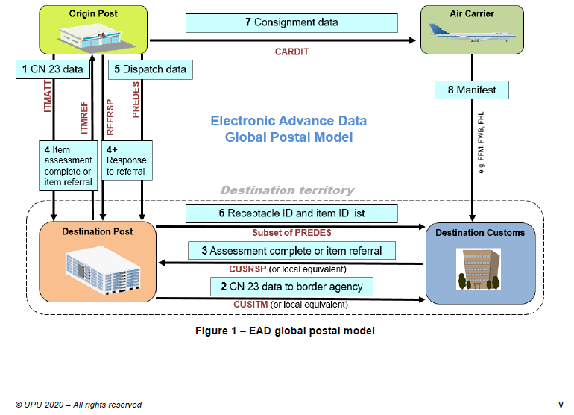

Figure 1: UPU EAD flowchart

## UPU Communication structures

UPU physical mail pipeline is accompanied by associated postal EDI (Electronic Data Interchange) messaging. EDI messages are used for exchange of data between different parties (postal operators) through the EDI network.

In UPU EAD Global Postal Model, the following EDI messages take part:

|  |  |
| --- | --- |
| **Message** | **Description** |
| ITMATT | ITeM ATTributes which is a digital representation of the UPU CN22/CN23 form (UPU Customs Declarations forms) |
| CUSITM | CUStoms ITeM contains the same information as ITMATT in a format requested by customs to perform risk assessments |
| CUSRSP | CUStoms ReSPonse is the answer from customs to the CUSITM |
| ITMREF/REFRSP | ITeM REFerral/REFerral ReSPonse are messages to communicate requests for referrals and responses to the requests, between the origin postal operator and the destination postal operator |
| PREDES | PREDES is the name of an EDI (electronic data interchange) message containing information on a mail dispatch (receptacle level) |
| Subset of PREDES[2] | Receptacle ID and Items ID lists prior issued PREDES |
| CARDIT | Carrier Documentation for International Transport sent by the origin post to the air carrier |

Table 4: UPU EDI messages in Global Postal Model

# ICS2

## ICS2 general description

ICS2 system supports implementation of new advance cargo information requirements under the Union Customs Code.

There are 2 types of risk analysis performed in the context of the entry of the goods into the EU process:

* Air pre-loading risk analysis:
  + focusing on the aviation security only
  + Using the PLACI - data on the goods from ITMATT - and receptacles from PREDES
* Pre-arrival risk analysis:
  + focusing on all other types of risks, e.g. security, safety of products, IPR, etc.
  + Using the full Entry Summary Declaration (ENS) - data on the goods from ITMATT - and receptacles from PREDES

**Air pre-loading risk analysis**

The risk assessment following the pre-loading (PLACI) data submission (ICS2 Release 1) is focused on the detection of an immediate security risk to aviation, which is the bringing on board of an aircraft of articles prohibited by aviation security legislation that could lead to the distortion of the plane and/or the loss of lives, e.g. an assembled improvised explosive or incendiary device (IED- IID), a ‘bomb in the box’.

The ICS2 ensures:

* the collection and analysis of advanced information on air cargo and mail that is bound to the EU prior of being loaded on board of an aircraft in a third country;
* electronic system based real time risk assessment of that information by the customs authorities;
* risk mitigation measures by customs and economic operators considered appropriate in relation to identified risk level for cargo and mail destined to enter the EU.

**Pre-arrival risk analysis**

ENS is required for customs to carry out risk analysis primarily for the public security, health and safety purpose.

The ICS2 system supports the following processes:

* lodgement of the ENS to customs;
* security & safety risk analysis by customs, including referrals to mitigate the identified risks,
* presentation of goods to customs;
* controls of goods by customs, if/where required.

## Entry process – Postal business model

In ICS2 Release 1, two ENS filings are to be used in the postal business model:

* **F43**: contains the house consignment information (to be generated **from ITMATT information**), (see [R03])
* **F44**: links house consignments to a receptacle ID that is used for transport (receptacle as part of the dispatch - to be generated from **PREDES information**)(see [R03])

Both ENS filings are to be lodged by the postal operator at destination (EU based postal operator). **Postal operators (as ENS declarants) need to address their ENS filings to the MS where they are established.**

ENS declarants will receive various notifications depending on the workflow progress of the individual transaction and the decisions the competent customs authority has taken on it, i.e.:

* Registration response (with MRN number) or error notification (in case of unsuccessful validation of the message);
* Assessment Complete notification (when RA was performed and DNL was not issued);
* DNL request (when serious risk was identified);
* RfI for amendment of the particulars (data quality and accuracy referral); known as RfI notification, and corresponding response to the request for information;
* RfS -> screening by applying defined EU Civil Aviation Security measures (HRCM); known as RfS notification and corresponding response to the request for HRCM screening.

ICS2 Release 1 – Postal business model describes mapping of ICS2 Release 1 messages to UPU EAD global postal model.

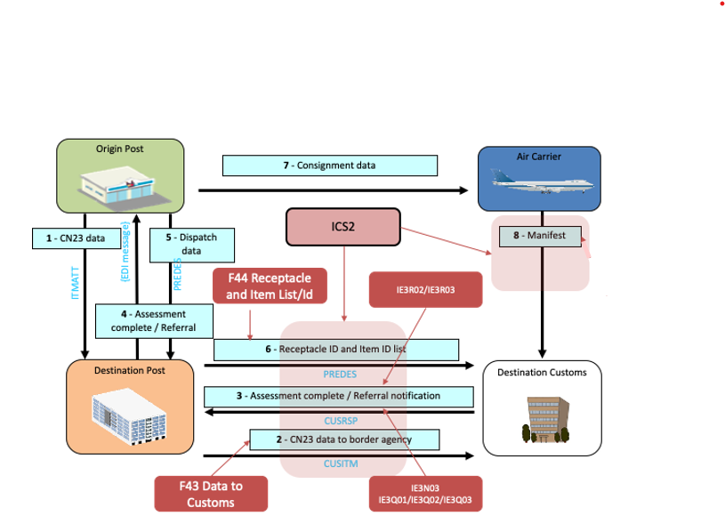

Figure 2: ICS2 message mapping to UPU EAD global postal model

### Steps of lodgement of ENS

* ITMATT is created and sent to destination post

Consignor/sender posts an item at Origin post for shipping. Origin post ensures that EAD (including all mandatory ICS2 Release 1 PLACI data elements) are provided by the Consignor/sender, then creates ITMATT and sends it to Destination post.

* Upon reception of ITMATT destination post uses ITMATT data to create an IE3F43 message and submits it to ICS2.
* After IE3F43 was received in ICS2

ICS2 performs syntactical, semantical and lifecycle validation of received IE3F43. In case of positive validation:

* IE3F43 is registered, stored and further processed by customs office of destination post, or
* Error messages IE3N99 or IE3N01 are sent to destination post in case lodged IE3F43 did not pass all validation procedures.

If error message is issued, IE3F43 was rejected by ICS2 and will not be further processed. Destination post shall lodge a completely new IE3F43 with the necessary corrections. The correction shall encompass all errors that were indicated in the IE3N99 error message.

* Air pre-loading risk analysis in ICS2

The customs office at the destination is performing air pre-loading risk analysis.

In some cases, the customs office may address referral requests to the person filing before taking a decision on the risk analysis results. For more details, please see Section 6.2.2.

* Results of air pre-loading risk analysis

After air pre-loading risk analysis was performed and decision made customs office at destination will submit to the destination post either:

* Assessment complete (AC) notification, or
* Do Not Load (DNL) request.
* Destination post is responsible for notifying the Origin post on risk analysis results.

Depending on notification received by origin post, the following actions should be taken:

* **Assessment complete was issued**: In case Customs office at destination has issued Assessment complete, origin post proceeds with the loading of items into the receptacles for the Destination post.

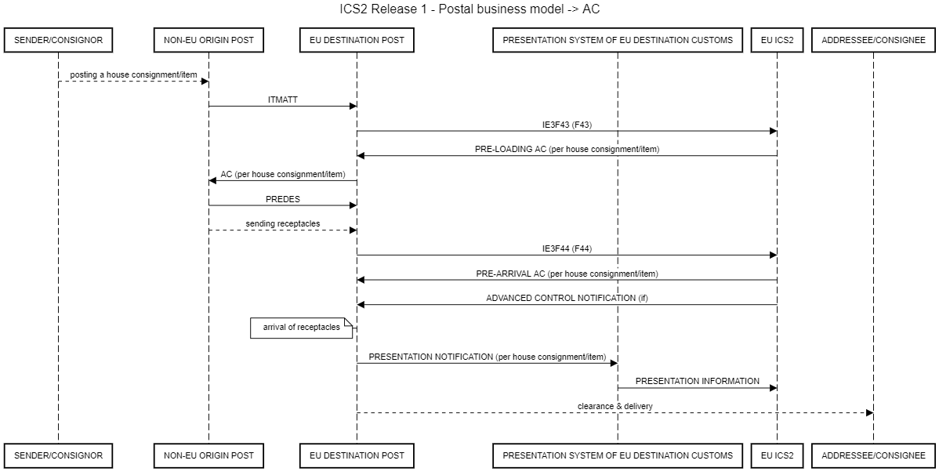

Figure 3: ICS2 R1 - Postal business model -> AC

* **Do not load was issued:** In case customs office at destination has issued a DNL, the destination post shall immediately inform the origin post, which then shall take the air cargo security measures according to their national legislation. In addition, it is highly recommended that destination post confirms with the customs office of destination the receipt of the DNL message.

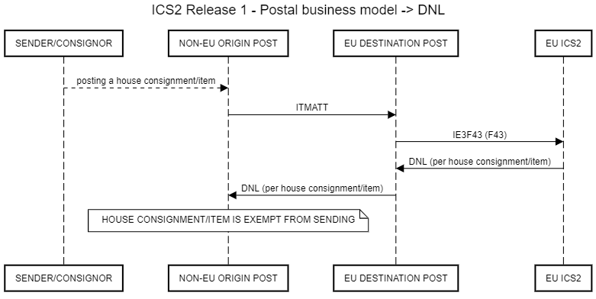

Figure 4: ICS2 R1 - Postal business model -> DNL

* **RA results not received yet:**
  + aforementioned messages are not received due to the technical reasons – in this case issue should be solved via incident management process and/or according to measures described in ICS2 Business continuity plan [R11];
  + origin post takes a business decision not to wait for aforementioned messages and send items on its own responsibility and risk.
* PREDES is created and sent to destination post

After origin post has inserted items into receptacles and prepared a dispatch for destination post, it issues relevant PREDES messages and sends it to destination post.

Origin posts shall send only correct PREDES messages (all items with goods are equipped with S10 barcodes and are nested into the receptacles).

* (EU) destination post lodges ENS filing - IE3F44 to ICS2

The destination post prepares and submits IE3F44 to ICS2.

* IE3F44 received in ICS2

ICS2 performs a syntactical, semantical and lifecycle validation of the received IE3F44. In case of positive validation:

* IE3F44 is stored and further processed by ICS2, or
* Error messages IE3N99 or IE3N01 are sent to post in case IE3F44 did not pass all validation procedures.

If error message has been sent IE3F44 is rejected by ICS2 and post issuing invalid IE3F44 has to submit a new IE3F44 with the necessary corrections. The correction shall encompass all errors that were indicated in the IE3N99 error message.

* Air pre-arrival risk analysis in ICS2

Pre-arrival risk analysis is performed.

In some cases, the customs may address referral requests (RfI) to the person filing before taking a decision on the risk analysis results. For more details, please see Section 6.2.2.

* Results of risk analysis

After pre-arrival risk analysis was performed and decision made customs office at destination will submit to the destination post Assessment complete (AC).

* Destination Post is responsible for notifying the Origin Post on risk analysis results.

More details of ICS2 information exchange are available in the document ICS2 HTI Information Exchange Specification [R03].

### Risk analysis by customs, including referrals

After IE3F43 was received in ICS2 addressed MS will be requested to perform:

* Air pre-loading or Air Cargo Security risk analysis;
* Air pre-arrival or Security & Safety risk analysis.

When pre-loading risk analysis is carried out there can be a need for:

* additional information or
* item should be diverted or temporarily stopped in order to perform HRCM screening procedures according to the ICAO specifications.

If this is the case, the customs office at destination who is performing the risk analysis will prepare a respective request (RfI or RfS) in ICS2 and will submit it to destination post.

Destination post shall provide response. Origin post shall support destination post in providing response to RfI and RfS requests (if necessary).

Descriptions of processes are provided in the document *EU guidance on air cargo security referral protocols* [R07].

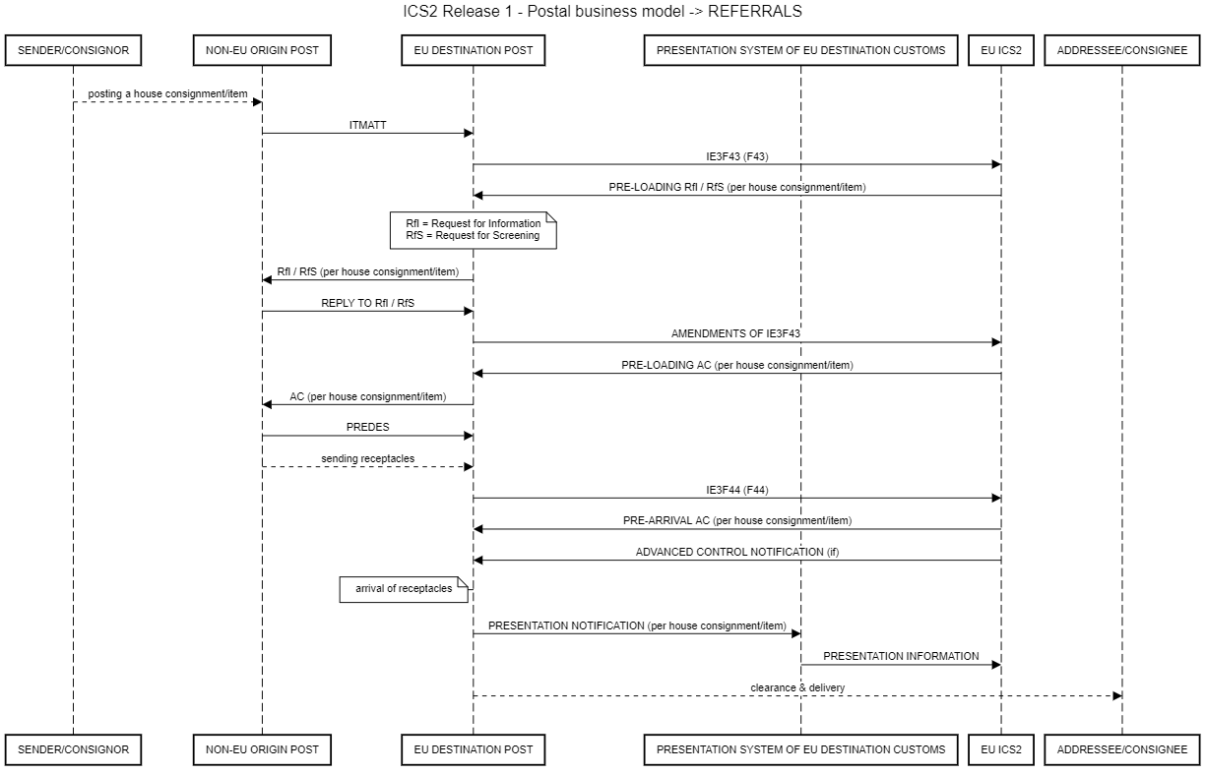

Figure 6: ICS2 R1 - Postal business model -> referrals

After air pre-loading risk analysis was performed customs will submit notification to the destination post (please see Section 6.2.1).

### Presentation of goods to customs

House consignments/items that arrive at the Office of Exchange from outside the EU customs territory need to be presented to the customs office at destination. Regarding the requirements of the presentation notification and means to be used, please consult the respective national customs administration. The presentation notification has to contain:

* MRN of the ENS (IE3F43);
* information on the presented house consignments/items (Transport document (house level) reference number and type).

Where no ENS was lodged for a presented item, the ENS is to be lodged immediately upon presentation, unless a waiver applies or the postal operator was granted a deployment window, which is valid at the point in time the ENS had to be lodged.

As a consequence of the presentation to customs no further amendments and invalidation requests can be made by the destination post for ENS filings covering the presented house consignments.

It may happen that not all house consignments/items indicated in presentation notification were actually presented. Presentation for these missing postal items (with S10 item number, which identifies the house consignment) need to be revoked.

### Control of goods by customs

Where control was not already notified in advance (only possible when EO is a holder of AEOS (AEOF) status) the customs office at destination will notify the destination post about requested controls.

### Subsequent customs procedure

After presentation of the items or where customs decided on a control, after performance of the control and if control results allow for, the items might be placed under a subsequent customs procedure in accordance with the relevant provisions for that procedure.

## Amendments of ENS

In general, there are two reasons for an amendment of the original ENS filing:

* a referral request for amendment (request type code AMD) or
* a need for amendment was identified by the destination post. This case will in particular be relevant when updated ITMATT information was submitted by origin post that alters data sent in IE3F43 ENS filing and when PREDES message does not match with the actual list of arrived house consignments.

Where the amendment was initiated by a referral request (AMD) the referral request reference has to be inserted in the respective amendment message. Else, the amendment will not be recognised as an answer to the original referral request by ICS2.

An ENS filing IE3F43 is to be amended by its respective amendment filing IE3A43 (see [R03]). Already amended original filings can be further amended. Sample messages of the amendment filings can be found in the referral guidance document [R07].

ITMATT standard rules allow sending updates of ITMATT messages. Message rules for lodging ENS filing have to be accordingly set up, so also updates of ITMATT are correctly transferred into ENS filing.

**Amendments of ENS filings are possible until either:**

* the goods covered by the ENS filing amendment are presented to customs, or
* where the customs office has already notified a control of item covered by the ENS amendment.

The amendment restrictions above apply to all house consignments/items contained in the original ENS filing. This means, if only one house consignment of the original ENS filing is presented, no house consignment/item contained in that ENS filing can be amended anymore. The same applies for notified controls.

Elements (classes and attributes) of the ENS filing where rule R3024[3] is assigned cannot be amended. For the IE3F43 the elements are:

* LRN
* Document issue date
* Specific circumstance indicator
* Addressed Member State
* Declarant/identification number
* Representative/identification number
* Transport document (House Level)

**F43 amendment**

No new house consignments can be introduced and no new goods items (item pieces) of an existing house consignment can be inserted. New house consignments/items are to be declared by new IE3F43. Where a need exists to declare additional goods items (item pieces) for an existing house consignment, the original filing IE3F43 needs to be invalidated by submitting an invalidation request (IE3Q04). After the invalidation acceptance response (IE3R07) was received, a new corrected IE3F43 can be submitted.

Where only some but not all house consignments are shipped an amendment of the respective original ENS filing can be sent which does not contain these house consignments anymore. The house consignments no longer present in the amendment filing will be invalidated by the ICS2 common components.

**F44 amendment**

PREDES is always sent from origin to destination post. PREDES message can be corrected with new PREDES message or other actions by destination postal operator. In case of a new PREDES message, the old PREDES message and old F44 filing have to be invalidated and a new F44 has to be lodged.

## Invalidation of ENS

There are three existing ways for invalidation of ENS:

* EO sends an invalidation request (IE3Q04) to ICS2. Where accepted, all house consignments of the respective ENS filing referred to in the invalidation request will be invalidated.
* All house consignments will be automatically invalidated after 200 calendar days from the registration date of the ENS filing if they were not presented to customs within this period.

Invalidation of ENS filings are possible until either:

* the goods covered by the ENS filing for invalidation have been presented to customs, or
* where the customs office has already notified a control for the goods covered by the ENS filing to be invalidated.

The invalidation restrictions above apply to all house consignments contained in the original ENS filing. This means, if only one house consignment of the original ENS filing is presented, no house consignment contained in that ENS filing can be invalidated anymore. The same applies for notified controls.

# Postal transit and ICS2

In Release 1 only the postal transit that ends in the EU (postal items delivered to the consignee in the EU) is in scope. The main principle of the ENS filing applies - the destination post is responsible to lodge both F43 and F44 filings to ICS2.

## Closed transit

Closed transit is when receptacles are consigned from the origin operator to the transit operator to be forwarded to destination.

### Non-EU – EU – EU

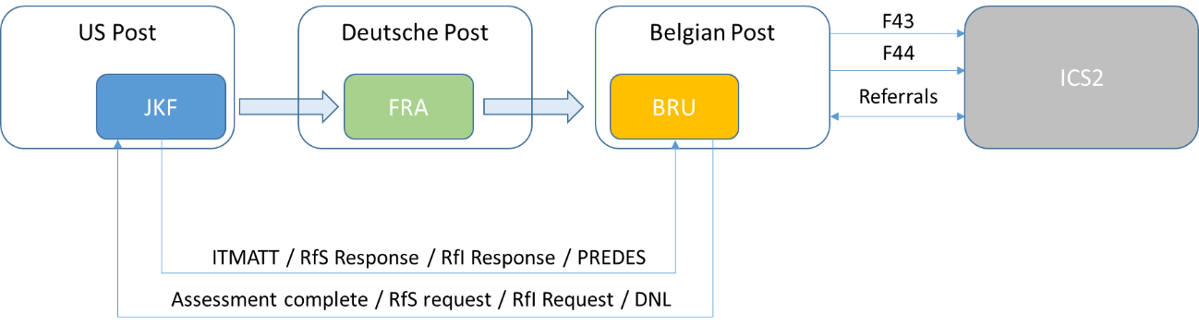

Figure 7: Transit scenario 1

* Origin postal operator sends ITMATT and PREDES to destination postal operator.
* Destination postal operator lodges F43 and F44 filings.
* ICS2 will perform risk analysis and send findings to destination operator (referrals) who shall forward them to origin postal operator.

The process above remains the same for receptacles that travel through more than one EU country in UPU closed transit, as transit EU countries have no obligations in ICS2 Release 1.

### Non-EU – non-EU – EU

* Origin postal operator sends ITMATT and PREDES to destination postal operator.
* Destination postal operator lodges F43 and F44 filings.
* ICS2 will perform risk analysis and send findings to destination postal operator (referrals) who shall forward them to origin postal operator.
* If in closed transit (in ICS2 Release 1) receptacles travel through more than one non-EU country process above remains the same, transit countries have no obligations.

## Open transit

In open transit items/house consignment or bundles of items for destination countries are included inside receptacles, addressed and dispatched to transit postal operator. The transit postal operator then includes these items in its own receptacles for destination postal operator.

### Non-EU – EU – EU

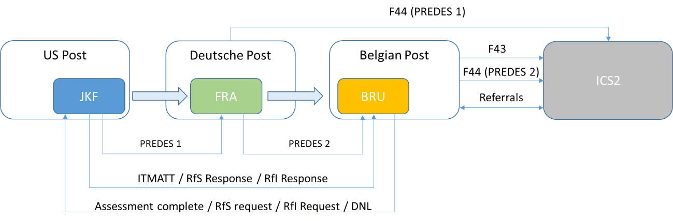

Figure 8: Transit scenario 2

* Origin postal operator sends ITMATT to destination post. Origin postal operator send PREDES to transit EU postal operator (PREDES 1).
* Transit EU postal operator opens the receptacles from origin post and makes new receptacles/dispatches for destination postal operator. Transit EU postal operator sends PREDES (PREDES 2) to destination postal operator.
* Destination postal operator lodges F43 and F44 (PREDES 2) filings.
* ICS2 will perform risk analysis and send findings to destination postal operator (referrals) who shall forward them to origin postal operator.
* If in open transit (in ICS2 Release 1) items travel through more than one EU country process is accordingly adjusted - destination post files F44 only for last transport leg PREDES.

### Non-EU – non-EU – EU

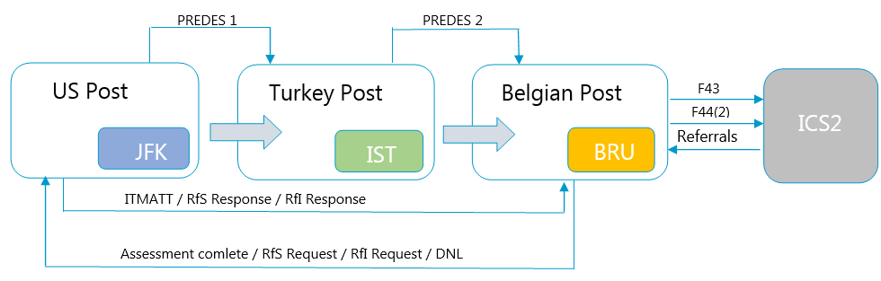

Figure 9: Transit scenario 3

* Origin postal operator sends ITMATT to destination postal operator. Origin postal operator send PREDES to transit non-EU postal operator (PREDES 1).
* Transit postal operator opens the receptacles and makes new receptacles for destination postal operator and sends PREDES to destination postal operator (PREDES 2).
* Destination postal operator lodges F43 and F44 (PREDES 2) filings.
* ICS2 will perform risk analysis and send findings to destination postal operator (referrals) who shall forward them to origin postal operator.

If in open transit (in ICS2 Release 1) items travel through more than one non-EU country process above remains the same, F44 is filed only by destination EU postal operator for last transport leg (last PREDES).

# Data requirements

In ICS2 Release 1 two ENS filings are to be used in the postal business model:

* **F43**: contains the house consignment information (to be generated **from ITMATT information**),
* **F44**: links house consignments to a receptacle ID that is used for transport (receptacle as part of the dispatch - to be generated from **PREDES information**)

Both ENS filings are to be lodged by the postal operator at destination (EU based postal operator).

## Data requirements – ITMATT

UPU standard named ITMATT (standard M33 - version 12) includes set of data elements, which correspond to the contents of postal customs declaration forms CN22 / CN23. Any of these forms are related to one single item/house consignment. Any previous versions of M33 are not up to date with ICS2 requirements. However, the rules how to exchange ITMATT M33-12 messages between posts promote that message for the particular item need not be sent in a single message. One ITMATT exchange (file) can support between 1 and 5000 individual items. Allowance is made for up to 9 associated documents and for up to 999 content-pieces.

It shall be stressed out that not all data elements are mandatory (by UPU requirements) and if data elements of ITMATT are not provided from origin post ENS filing F43 cannot be lodged within pre-loading phase. Should origin post nevertheless dispatch such items, ENS filings must be lodged upon arrival to destination EU country, meaning that missing data elements shall be provided by ENS declarants (either from paper UPU forms CN22/CN23, pasted on the items or by requesting data from consignees/addressees).

For ICS2 Release 1 the minimum required data set from CN22/23 is:

1. Sender Name
2. Sender Address
3. Recipient Name
4. Recipient Address
5. Number Of Articles
6. Total Gross Weight
7. Description Of Contents
8. Postal Item Identifier, in most cases for international shipments, the S10 identifier

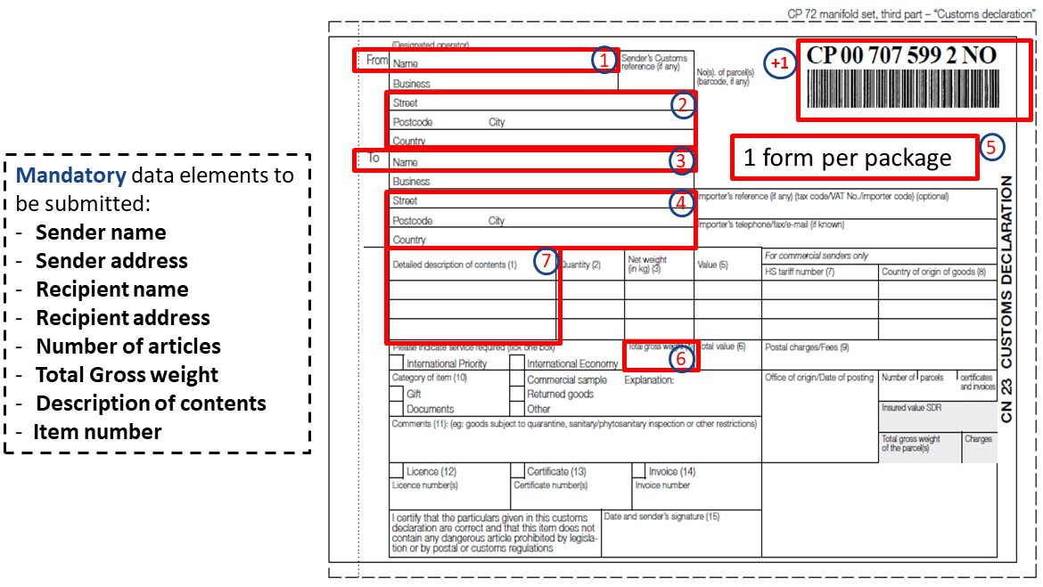

Figure 10: Minimum required data for ICS2 Release 1

Postal operators, receiving ITMATT messages, can map more then 7+1 data elements into ICS2.

Mapping of data elements is shown in Annex 1.

## Data requirements − PREDES

UPU standard named PREDES v 2.1 (M41 version 7) includes various sets of data elements. To clarify PREDES rules and usage other UPU standards need to be read simultaneously: M84 – Logical Data Model and M30 – Electronic Data Interchange between Postal Handling Organizations.

PREDES message contains information about a despatch of mail, which has been prepared by origin post’s office of exchange for transportation to a destination post’s office of exchange, typically in another country.

UPU postal operators shall use PREDES v 2.1., any other version is not up to date for ICS2.

Mapping of data elements is shown in Annex 2.

## Data requirements − Missing data elements

In case the PLACI data elements (ICS2 Release 1) are incomplete (i.e. missing mandatory data elements) or are not in line with the agreed ICS2 system specifications, the ENS filing is rejected and an error message is sent to the EO.

This means that EO has not complied with the data requirements. The EO needs to ensure to act upon such an error message as early as possible and to provide within the legally required time limits the required PLACI data.

In the case of technical issues, where EO considers that data has been sent compliant with the requirements, the EO should contact as early as possible the ICS2 National Helpdesk of the Member State customs authority to which data was addressed.

If the necessary data have not been submitted to ICS2, the ENS will have to be submitted at the latest at the presentation of the goods. The goods will not be release for subsequent customs procedure before the entry formalities have been completed.

# Annexes

## Annex 1 – Mapping data elements ITMATT – ENS

|  |  |  |  |  |
| --- | --- | --- | --- | --- |
| **No** | **ITMATT data element name (ITMATT M33-12)** | **Pre-loading** | **Pre-arrival** | **ICS2 data element name** |
|  |  |  |  | **IE3F43 = official code of filing F43** |
| 1 | **Not part of ITMATT** |  |  | **LRN/local reference number** |
| 2 | **Not part of ITMATT** |  |  | **Document issue date** |
| 3 | **Not part of ITMATT** |  |  | **Specific circumstance indicator** |
| 4 |  |  |  | **Addressed Member State** |
| 4.1 | **addressee.postal-address.country-code**  **(ISO 3166-1 two character country code)** |  |  | **Country** |
| 5 | **If included in ITMATT then under**  **Item.service-contractor-party.identifier** |  |  | **Representative** |
| 5.1 | **Not part of ITMATT** |  |  | **Name** |
| 5.2 | **Not part of ITMATT** |  |  | **Identification number** |
| 5.3 | **Not part of ITMATT** |  |  | **Status** |
| 5.4 |  |  |  | **Address** |
| 5.4.1 | **Not part of ITMATT** |  |  | **City** |
| 5.4.2 | **Not part of ITMATT** |  |  | **Country** |
| 5.4.3 | **Not part of ITMATT** |  |  | **Sub-division** |
| 5.4.4 | **Not part of ITMATT** |  |  | **Street name line 1** |
| 5.4.5 | **Not part of ITMATT** |  |  | **Postcode** |
| 5.4.6 | **Not part of ITMATT** |  |  | **Street name line 2** |
| 5.4.7 | **Not part of ITMATT** |  |  | **Number** |
| 5.4.8 | **Not part of ITMATT** |  |  | **P.O. Box** |
| 5.5 |  |  |  | **Communication** |
| 5.5.1 | **Not part of ITMATT** |  |  | **Identifier** |
| 5.5.2 | **Not part of ITMATT** |  |  | **Type** |
| 6 | **Possible in ITMATT in**  **Event.associated-entity.ID or**  **event.associated-entity.type** | **R1-F44** |  | **Consignment (Master level)** |
| 6.1 | **Item.ID.value (UPU S10 item ID)** | **F43** |  | **Consignment (House level)** |
| 6.1.1 | **Item.declared-gross-weight or**  **Item.measured-gross-weight** |  |  | **Total gross mass** |
| 6.1.2 |  |  |  | **Additional fiscal references** |
| 6.1.2.1 | **Could be in: Addressee.identification.reference** |  |  | **VAT identification number** |
| 6.1.2.2 | **Addressee.role (but in UPU always CN=consignee)** |  |  | **Role** |
| 6.1.3 | **Item.associated-document.type** |  |  | **Supporting documents** |
| 6.1.3.1 | **Item.associated-document.identifier** |  |  | **Reference number** |
| 6.1.3.2 | **Item.associated-document.name** |  |  | **Type** |
| 6.1.4 |  |  |  | **Additional information** |
| 6.1.4.1 |  |  |  | **Code** |
| 6.1.4.2 | **Item.observations** |  |  | **Text** |
| 6.1.5 |  |  |  | **Additional supply chain actor** |
| 6.1.5.1 | **Not part of ITMATT** |  |  | **Identification number** |
| 6.1.5.2 | **Not part of ITMATT** |  |  | **Role** |
| 6.1.6 |  |  |  | **Consignee** |
| 6.1.6.1 | **Addressee.identification.name +**  **Addressee.identification.additional-data (up to 4x)** |  |  | **Name** |
| 6.1.6.2 | **Addressee.identification.reference** |  |  | **Identification number** |
| 6.1.6.3 |  |  |  | **Type of person** |
| 6.1.6.4 |  |  |  | **Address** |
| 6.1.6.4.1 | **Addressee.postal-address.locality name** |  |  | **City** |
| 6.1.6.4.2 | **addressee.postal-address.country-code**  **(ISO 3166-1 two-character country code)** |  |  | **Country** |
| 6.1.6.4.3 | **Addressee.postal-address.locality.region** |  |  | **Sub-division** |
| 6.1.6.4.4 | **Addressee.postal-address.premises (up to 4x)**  **(e.g.street & number)** |  |  | **Street name line 1** |
| 6.1.6.4.5 | **Addressee.postal-address.locality.code** |  |  | **Postcode** |
| 6.1.6.4.6 | **Addressee.postal-address.premises (up to 4x)**  **(additional specification of address)** |  |  | **Street name line 2** |
| 6.1.6.4.7 | **Addressee.postal-address.premises** |  |  | **Number** |
| 6.1.6.4.8 | **Addressee.postal-address.premises** |  |  | **P.O. Box** |
| 6.1.6.5 |  |  |  | **Communication** |
| 6.1.6.5.1 | **3 options: addressee.contact.email or**  **Addressee.contact.telephone or**  **Addressee contact.fax (all up to 3x)** |  |  | **Identifier** |
| 6.1.6.5.2 | **Not part of ITMATT** |  |  | **Type** |
| 6.1.7 |  |  |  | **Goods item** |
| 6.1.7.1 | **Content-piece.number** |  |  | **Goods item number** |
| 6.1.7.2 |  |  |  | **Postal value** |
| 6.1.7.2.1 | **Content-piece.declared-value.amount** |  |  | **Value** |
| 6.1.7.2.2 | **con Content-piece.declared-value.currency** |  |  | **Currency** |
| 6.1.7.3 | **Item.nature-of-transaction-code (UPU CL 136)** |  |  | **Type of goods** |
| 6.1.7.4 |  |  |  | **Commodity** |
| 6.1.7.4.1 | **Content-piece.description** |  |  | **Description of goods** |
| 6.1.7.4.2 |  |  |  | **CUS code** |
| 6.1.7.4.3 |  |  |  | **Commodity code** |
| 6.1.7.4.3.1 | **Content-piece.tariff-heading** |  |  | **Harmonized System sub-heading code** |
| 6.1.7.4.3.2 | **Content-piece.tariff-heading** |  |  | **Combined nomenclature code** |
| 6.1.7.5 |  |  |  | **Weight** |
| 6.1.7.5.1 | **Content-piece.net-weight** |  |  | **Net mass** |
| 6.1.7.6 |  |  |  | **Country of origin** |
| 6.1.7.6.1 | **Content-piece.origin-location.code**  **(ISO 3166-1 country code)** |  |  | **Country** |
| 6.1.7.7 |  |  |  | **Packages** |
| 6.1.7.7.1 | **By default, for post: always 1** |  |  | **Number of packages** |
| 6.1.8 |  |  |  | **Consignor** |
| 6.1.8.1 | **sender.identification.name +**  **sender.identification.additional-data (up to 4x)** |  |  | **Name** |
| 6.1.8.2 | **sender.identification.reference** |  |  | **Identification number** |
| 6.1.8.3 |  |  |  | **Type of person** |
| 6.1.8.4 |  |  |  | **Address** |
| 6.1.8.4.1 | **sender.postal-address.locality name** |  |  | **City** |
| 6.1.8.4.2 | **sender.postal-address.country-code**  **(ISO 3166-1 two-character country code)** |  |  | **Country** |
| 6.1.8.4.3 | **sender.postal-address.locality.region** |  |  | **Sub-division** |
| 6.1.8.4.4 | **sender.postal-address.premises (up to 4x)**  **(e.g.street & number)** |  |  | **Street name line 1** |
| 6.1.8.4.5 | **sender.postal-address.locality.code** |  |  | **Postcode** |
| 6.1.8.4.6 | **sender.postal-address.premises (up to 4x)**  **(additional specification of address)** |  |  | **Street name line 2** |
| 6.1.8.4.7 | **sender.postal-address.premises** |  |  | **Number** |
| 6.1.8.4.8 | **sender.postal-address.premises** |  |  | **P.O. Box** |
| 6.1.8.5 |  |  |  | **Communication** |
| 6.1.8.5.1 | **3 options: addressee.contact.email or**  **Addressee.contact.telephone or**  **Addressee contact.fax (all up to 3x)** |  |  | **Identifier** |
| 6.1.8.5.2 | **Not part of ITMATT** |  |  | **Type** |
| 6.1.9 |  |  |  | **Postal charges** |
| 6.1.9.1 | **Item.postage-paid.amount** |  |  | **Postal charges** |
| 6.1.9.1.1 | **Item.postage-paid.amount** |  |  | **Value** |
| 6.1.9.1.2 | **Item.postage-paid.currency** |  |  | **Currency** |
| 6.1.10 |  |  |  | **Transport document (House level)** |
| 6.1.10.1 | **Event.associated-entity.ID** |  |  | **Reference number** |
| 6.1.10.2 | **Event.associated-entity.type** |  |  | **Type** |
| 6.1.11 |  |  |  | **Reference number/UCR** |
| 16.1.11.1 | **Not part of ITMATT** |  |  | **Reference number/UCR** |
| 7 |  |  |  | **Declarant** |
| 7.1 | **Not part of ITMATT** |  |  | **Name** |
| 7.2 | **Not part of ITMATT** |  |  | **Identification number** |
| 7.3 |  |  |  | **Address** |
| 7.3.1 | **Not part of ITMATT** |  |  | **City** |
| 7.3.2 | **Not part of ITMATT** |  |  | **Country** |
| 7.3.3 | **Not part of ITMATT** |  |  | **Sub-division** |
| 7.3.4 | **Not part of ITMATT** |  |  | **Street name line 1** |
| 7.3.5 | **Not part of ITMATT** |  |  | **Postcode** |
| 7.3.6 | **Not part of ITMATT** |  |  | **Street name line 2** |
| 7.3.7 | **Not part of ITMATT** |  |  | **Number** |
| 7.3.8 | **Not part of ITMATT** |  |  | **P.O. Box** |
| 7.4 |  |  |  | **Communication** |
| 7.4.1 | **Not part of ITMATT** |  |  | **Identifier** |
| 7.4.2 | **Not part of ITMATT** |  |  | **Type** |

## Annex 2 – Mapping data elements PREDES – ENS

|  |  |  |
| --- | --- | --- |
| **Occurs** | **PREDES data element name** | **ICS2 data element name** |
|  |  | **IE3F44 = official code of filing F44** |
| 1 | **Not part of PREDES** | **LRN/local reference number** |
| 2 | **Not part of PREDES** | **Document issue date** |
| 3 | **Not part of PREDES** | **Specific circumstance indicator** |
| 4 |  | **Addressed Member State** |
| 4.1 | **Despatch-ID** | **Country** |
| 5 |  | **Representative** |
| 5.1 | **Not part of PREDES** | **Name** |
| 5.2 | **Not part of PREDES** | **Identification number** |
| 5.3 | **Not part of PREDES** | **Status** |
| 5.4 |  | **Address** |
| 5.4.1 | **Not part of PREDES** | **City** |
| 5.4.2 | **Not part of PREDES** | **Country** |
| 5.4.3 | **Not part of PREDES** | **Sub-division** |
| 5.4.4 | **Not part of PREDES** | **Street name line 1** |
| 5.4.5 | **Not part of PREDES** | **Postcode** |
| 5.4.6 | **Not part of PREDES** | **Street name line 2** |
| 5.4.7 | **Not part of PREDES** | **Number** |
| 5.4.8 | **Not part of PREDES** | **P.O. Box** |
| 5.5 |  | **Communication** |
| 5.5.1 | **Not part of PREDES** | **Identifier** |
| 5.5.2 | **Not part of PREDES** | **Type** |
| 6 | **Despatch.ID** | **Consignment (Master level)** |
| 6.1 |  | **Consignment (House level)** |
| 6.1.1 |  | **Receptacle** |
| 6.1.1.1 | **Receptacle-ID** | **Receptacle identification number** |
| 6.1.2 |  | **Additional information** |
| 6.1.2.1 |  | **Code** |
| 6.1.2.2 |  | **Text** |
| 6.1.3 |  | **Transport document (House level)** |
| 6.1.3.1 | **Conveyance-reference** | **Reference number** |
| 6.1.3.2 | **Mode-of -transport** | **Type** |
| 7 | **Postal operator as ENS declarant can be extracted from dispatch-ID (destination IMPC)** | **Declarant** |
| 7.1 |  | **Name** |
| 7.2 |  | **Identification number** |
| 7.3 |  | **Address** |
| 7.3.1 |  | **City** |
| 7.3.2 |  | **Country** |
| 7.3.3 |  | **Sub-division** |
| 7.3.4 |  | **Street name line 1** |
| 7.3.5 |  | **Postcode** |
| 7.3.6 |  | **Street name line 2** |
| 7.3.7 |  | **Number** |
| 7.3.8 |  | **P.O. Box** |
| 7.4 |  | **Communication** |
| 7.4.1 |  | **Identifier** |
| 7.4.2 |  | **Type** |

*End of document*

1. ETOE policies and rules will be added at later stage
2. This message is today not clearly defined by UPU
3. This class/attribute cannot be amended.