BCP Communicator
Abbreviations and terms
Term | Explanation
AES | Automated Export System - European Teleinformation System that is supposed to AES include all operations related to goods leaving European Union territory.
AIS/ICS | Automated Import System component
BCP | Abbreviation established on the basis of the European Commission arrangements ( ”Business Continuity Plan”)
Gateway B2A | Gateway Business to Administration – communication component dedicated to entities to communicate with SISC operating systems
ECS2/ICS | Integrated Export and Import System
E-mail | An electronic mail service that allows you to send messages over the Internet using predefined network protocols.
Non-visual interface | Interface for automatic communication with the entities’ system by web service. The interface provides possibility of sending messages to the SISC operating systems, retrieving the result of the message sending, retrieving the list of documents, retrieving "the lost message package"
www interface | Can be used for electronic communication with SISC operating systems. Provides basic support for sending messages to the SISC operating systems, viewing messages, retrieving messages.
Entity | Company, customs agency (also organization, institution) that communicate electronically by exchanging messages with SISC operating systems.  The entity is not a direct actor here but acts through an established representative (natural person) using the entities’ system and / or www interface.
PUESC | Electronic Services Portal of the Customs and Tax Service
Representative | Natural person (e.g. employee, customs agent) acting on behalf of an entity that exchanges messages with the SISC operating systems.  A representative can act on behalf of many entities.
SISC | Information System of Customs and Taxes
SISC operating System | One of the SISC Systems (e.g. AES, AIS/ICS)
Entity System | IT system used by the representative for electronic communication with SISC operating systems.
WebService (SOAP) | It is a W3C standard, communication protocol that uses XML to encode calls and most commonly HTTP to carry them, but it is possible to use other protocols for data transport.

Introduction
The BCP Communicator is a communication component, built on the basis of the ECS2 / ICS IT solution, dedicated to entities communication with SISC operating systems as an alternative tool to PUESC.
The need for the communicator was related to the requirements arising from the European Commission Business Continuity Plan (BCP) where the EU introduced the point by explaining that business continuity arrangements will have to be made for the case of non-availability of electronic systems. The document refers to the provisions in Art.6 of the EU Customs Code (UCC). Potentially in the future the communicator may be used by any of SISC operating systems, however in the first phase it can only be used for communication with AIS/ICS and AES.
The assumption proposed by the Ministry of Finance foresees that the BCP communicator will be available for the time of deployment of AES System, as the additional tool for the communication.
Information about the tests and Communicator usage in the production environment (e.g. parallel to PUESC) will be provided in the separate newsletter.
However, one should keep in mind that the basic assumption of using a BCP is that if the initiating message was sent by PUESC, the whole operation must be terminated by PUESC. Similarly, if the BCP communicator initiates the process, then the electronic operation must be completed using this tool
It is not obligatory to build IT solutions that enable the usage of the BCP Communicator on the side of the entity. However, the Customs Department of MoF , in the perspective of deployment of AES and AIS / ICS systems, recommends building such the alternative communication solution.

What to do to use BCP communicator?
- Unregistered entity:
You need to register using the forms available on PUESC (test environment: https://test.puesc.gov.pl/;production environment: https://puesc.gov.pl/). Select from the menu 'Forms’>’eForms’>’e-Customer’, select the form from the list and fill in the appropriate one.
- Registered entity:
Login and password remain the same
- There are three ways to send customs declarations: via email, through a website, or a non-visual interface.
- Messages can be received via:
- Website-in any case,
- E-mail-if the email address for transmission has been given in the business message in “EmailPodmiotu” attribute ,By "pooling", i.e. querying the B2A gateway for messages package through the non-visual interface (webservice on the B2A gateway side) -
- If the “PlacowkaPodmiotu” attribute was given in the business message,
- Sending back messages to the entity via a non-visual interface (webservice on the side of the entities’ system). To do this, select the communication channels section when registering or updating the entity on PUESC. As the type of the channel, specify webservice-BCP entering the address of your own webservice to which the messages will be sent, then fill in the remaining fields marked as mandatory.
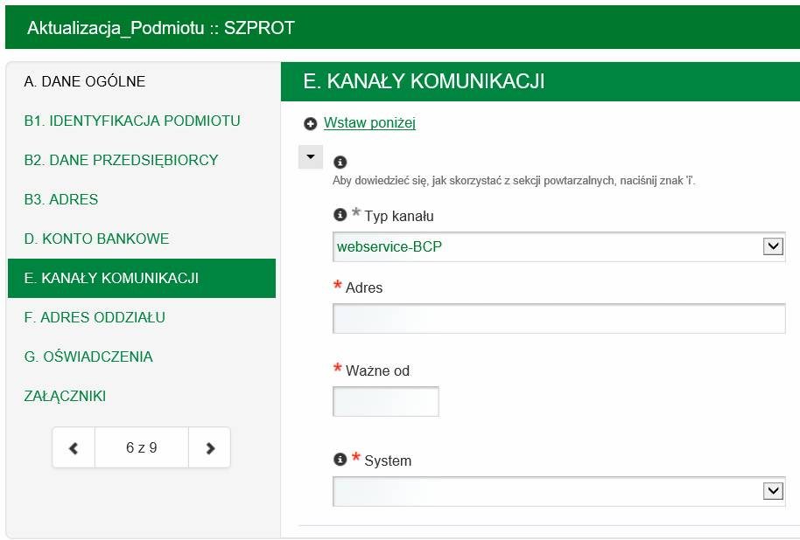
- In order to use the non-visual interface, you also need to change the B2A Gate-way standard (relative to the non-visual interface ECS2/ICS) from JAX-RCP to JAX-WS in the entity software.

B2A Gateway Services
Supported communication channels:
  - WebService (SOAP): https://bcp.mf.gov.pl/bcpWS/BcpService
  - E-mail: inbox@bcp.mf.gov.pl
  - Interface www: https://bcp.mf.gov.pl/
Test environment:
  - WebService (SOAP): https://testbcp.mf.gov.pl/bcpWS/BcpService
  - E-mail: test.inbox@bcp.mf.gov.pl
  - Interface www: https://testbcp.mf.gov.pl/

I Sending declarations from a trader to the SISC operating system.
A representative prepares and, if required, signs the declaration dedicated to one of the SISC operating systems in the entity’s system or on the Internet website and then sends it.
Entity’s IT system (or visual interface) generates the method “AcceptDocument” of the B2A Gateway service. As a parameter, the following is provided:
- content of a message being sent ( in Base64 format)
- MIME type
- description (optional)
- type of compression (if used)
Alternatively, a declaration might be sent as an email attachment from entity’s IT system. It is possible to send many attachments in one e-mail message.
B2A Gateway validates basic data only:
- if a message is a well-formed XML document
- if a message is recognizable ( check namespace and name of an element)
After basic validation, B2A Gateway gives a synchronous response –“AcceptDocumentResponse”.
If a message is received as an email attachment/s by B2A Gateway, an email response with attachments is submitted to the sender. The response includes following technical information:
- validation result ( acceptance for further processing or rejection)
- unique ID “orderld” which is assigned to each message receiver by B2A Gateway
- shortcut (hash SHA-1) of the received message
If validation is successful, B2A Gateway routes the message to the appropriate SISC operating system.
SISC operating system accepts the message immediately (without any validation) and to send synchronous response – “ AcceptDocumentResponse”.
In case of any problems with communication or unavailability of the SISC operating system, B2A Gateway will repeat sending of the message until it is successful.
SISC operating system is responsible for full validation of the message after it is received (i.e. after sending the response “SISCGateway.AcceptDocumentResponse”).As a result, a business response about the approval or rejection is sent asynchronously.
Full message validation includes checking of the following:
- schema compatibility
- values defined with codes
- reference data
- electronic signature
- authorisation of the representative who has signed document on entity’s behalf
- business rules (published in technical specification XML)
- other business rules provided by SISC operating systems
II Sending declaration from SISC operating system to the trader.
After receiving a request to send the message to the entity, B2A Gateway uploads the message along with attachments and loads channels of communication defined on PUESC for a given entity.
Then, B2A Gateway executes suitable actions for all communication channels registered on PUESC and delivered by SISC operating system.
For webservice-BCP channels, B2A Gateway generates the method “AcceptDocument” of “TraderGateway” service made available by entity’s system.
As a parameter, the following is provided:
- content of a message with metadata
- if applicable, attachment to the message with metadata
- the original identifier is added in "correlationOrderId"
Next, entity’s system responds synchronously using “Trader Gateway.AcceptDocumentResponse”.
In case of any problems with communication or unavailability of entity’s operating system, B2A Gateway is obliged to repeat sending of the message a given number of times at regular intervals (parameters set by B2A Gateway). If all repeated attempts fail, the sending of the data can be renewed manually on demand by the B2A Gateway administrator.
B2A Gateway creates individual email messages for every declaration sent via e-mail channels (if the declaration includes the email address to be used).
Regardless of channels assigned to the entity, messages can be loaded into the entity’s system by manual “pooling”.
At the end of the process, entity will be able to view every message received from SISC operating system in its own system.

III Pooling
If entity’s system does not facilitate the service ”Trader Gateway” and does not implement email communication, it is possible to pool messages from SISC operating system through query B2A Gateway This option is always available regardless of communication channels assigned in PUESC.
To upload not yet received messages, entity’s system uses the “GetDocuments” method of the B2A Gateway service with following parameters:
- optionally, the date from which the search for not yet loaded messages should start (if not provided, a default date is used)
- trader’s identifier
- PlacowkaPodmiotu attribute
To generate the above mentioned method, the representative’s login and password must be provided.
B2A Gateway authenticates representatives and checks their authorizations towards given entity as defined on PUESC.
B2A Gateway stores information about already uploaded messages to exclude them from future searches. Each batch of uploaded messages is given a unique number.
As a result, B2A Gateway responds synchronously through ”GetdocumentsResponse” with following information:
- download messages with their attachments (if any) and metadata
- the original identifier is added in "correlationOrderId"
- next batch number assigned to messages.
Number of messages loaded in a single request is limited in terms of amount and size. Information about not yet uploaded messages is provided inside the batch.
In case of any authentication and authorization failures , processing is stopped and the appropriate error message is sent out.
Should the need arise to upload the whole batch/batches once again, the entity can use the “GetLostDocuments” method of the B2A Gateway service. To generate this method, the batch number and trader’s ID must be entered.

IV Checking message status.
If the SISC operating system works properly, business confirmation/rejection is released in the form of the asynchronous reply.
Unusual events may occur when the SISC operating system is not running well then the rejection messages will not arrive immediately
If there is no business response, a representative may request checking the message status. To do this, entity’s system/ visual interface /uses the ”GetAcceptDocumentStatus” method of B2A Gateway service. “OrderId” received in technical acknowledgement is used as a parameter in this case.
B2A Gateway cooperates with SISC operating system and it is possible to check message status based on the entered “OrderId”. Simultaneously, B2A Gateway verifies if first feedback message exists. If yes, then the feedback message is returned synchronically in the “GetAcceptDocumentStatusResponse” message.
Should you need further information, please contact us @ aes.ais.projekt@mf.gov.pl

